1. Write a paragraph proof.

Given: ∠T and ∠V are right angles.
Prove: ∆TUW ∆VWU
​
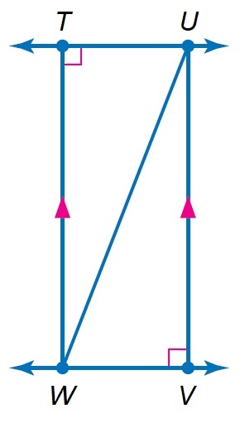

2. Sled kites rely on wind pressure to retain the shape of the sail. Each consists of a single square and two triangular pieces. Kyle has made a model of a Sled kite as shown below. Show that the angles and are congruent.
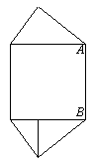(JUSTIFY)

3. A ray of light is reflected when it hits a mirror. The angle at which the light strikes the mirror is the angle of incidence, i. The angle at which the light is reflected is the angle of reflection, r. The angle of incidence and the angle of reflection are congruent. In the diagram below, if , what is the angle of reflection and
​
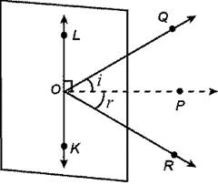 (JUSTIFY)

4. Samantha has cut a pastry into four parts. Suppose and T is the midpoint of PR. Determine whether Justify your answer.
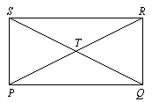

5. A pathway divides a rectangular garden into two parts as shown. Find the measure of
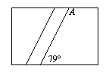
(JUSTIFY)

6. Andy was playing a memory game with his sister. He turned over a tile to reveal a picture of the sun at the coordinates (5, 4). He looked under a tile that was 3 units to the left and 2 units down but revealed a picture of a tree. His sister knew that the other sun was 1 unit to the left and 1 unit up from the tree. What are the coordinates of the second sun?
(JUSTIFY)

7. Carpenters use parallel wall studs to build support for walls. A carpenter has built two wall studs given by HG and CD in the figure below. Find the measure of so that the two wall studs are parallel.
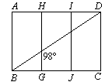
(JUSTIFY)

8. Richard ordered a coffee table that was a regular pentagon. Find the measure of an exterior angle of the table.
(JUSTIFY)

9. Let be the median of LMBA. Find , , and . (JUSTIFY)
Use trapezoid ABCD to find each measure.
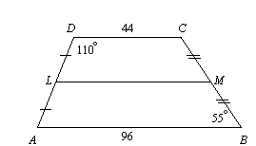

10. In a museum, Nick is looking at a famous painting through a mirror at an angle of Find the angle the painting makes with the mirror. Also find and (JUSTIFY)
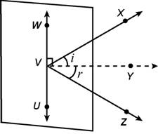

11. If a bike tire has 16 spokes spaced evenly apart, name its angles of rotation.
(JUSTIFY)
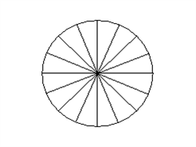

12. Richard wants to buy a LCD flat panel monitor measuring 14 inches by 16 inches. What is the measure of the diagonal of the monitor?
(JUSTIFY)

13. Samantha’s rectangular gift is 10 inches. by 12 inches and is framed with a ribbon. She wants to use the same length of ribbon to frame a circular clock. What is the maximum radius of the circular clock? Round to the nearest whole number.
(JUSTIFY)

14. Write a two-column proof.

Given: is the perpendicular bisector of
Prove:
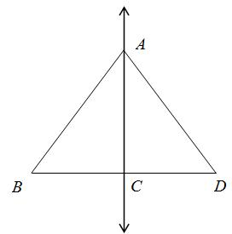

15. Write a flow proof.
Given:
Prove:
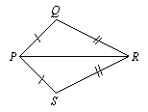

16. Find the coordinates of the orthocenter of ΔYAB that has vertices at Y(3, –2), A(3, 5), and B(9, 1). (JUSTIFY)

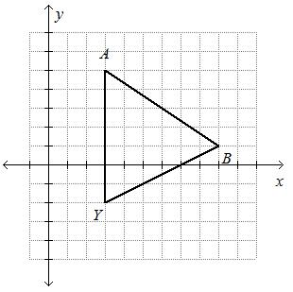

17. For isosceles trapezoid ABCD, find the length of the median and .(JUSTIFY)
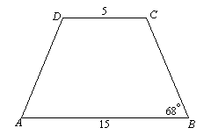

18. Write a two-column proof.
​
Given:
and are rt.
Prove: ∆ABC ∆ADC

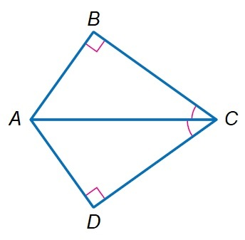

19. A salesperson travels from city A to city B and then to city C. From city C, the salesperson travels directly back to city A as shown in the diagram below. Write the lengths of the legs of the trip in order from least to greatest. (JUSTIFY)
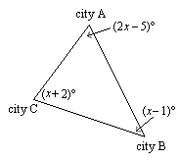

20. A construction manager moved a shed to the back corner of a lot. Because there were so many trees in the way, the construction manager had to move it 6 units up, 2 units to the left, 2 units down, and 3 units to the left. The vertices are now (5, 5), (0, 5), (5, 3), and (0, 3). What were the original vertices of the shed?
(JUSTIFY)

